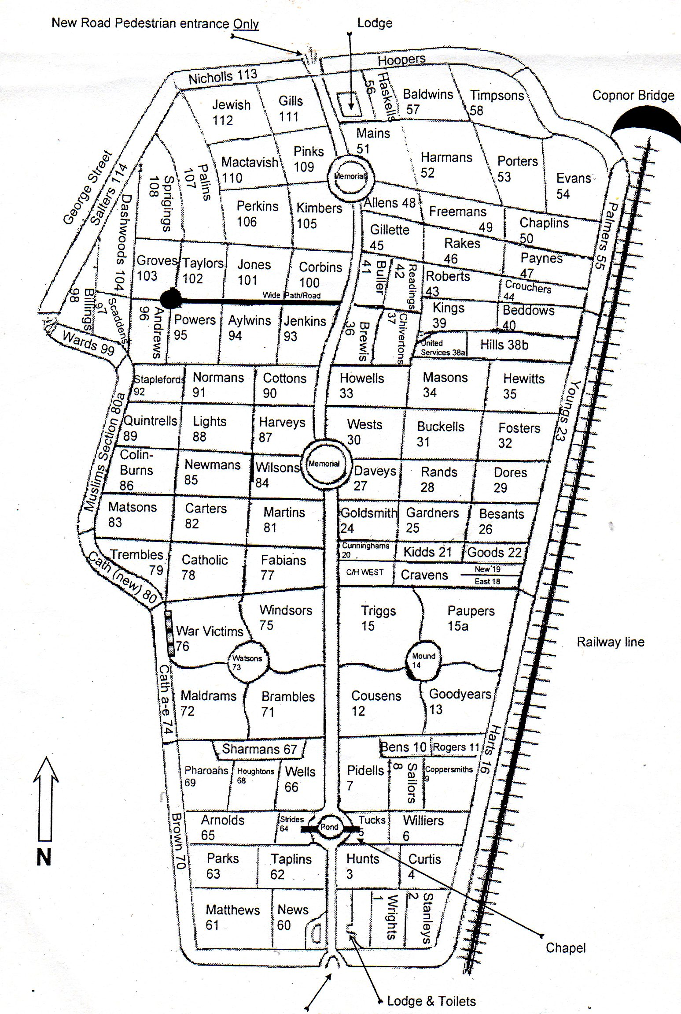

PLAN OF KINGSTON CEMETERY, ST. MARY’S ROAD, PORTSMOUTH

